Manual for Great Food Delivery 1
INTRODUCTION 1
GETTING STARTED WITH THE APP 2
PLACING AN ORDER 2
MANAGING YOUR CART 4
MAKING A PAYMENT 5
VIEWING YOUR RECEIPT 6

Manual for Great Food Delivery

INTRODUCTION
Hello there, welcome to the use of our food delivery app. This manual will guide you to choose from your favorite dish and how to use the application.

GETTING STARTED WITH THE APP
Sign Up/Login: Get the app active and set up a new account by entering your details or login if you already have an account.

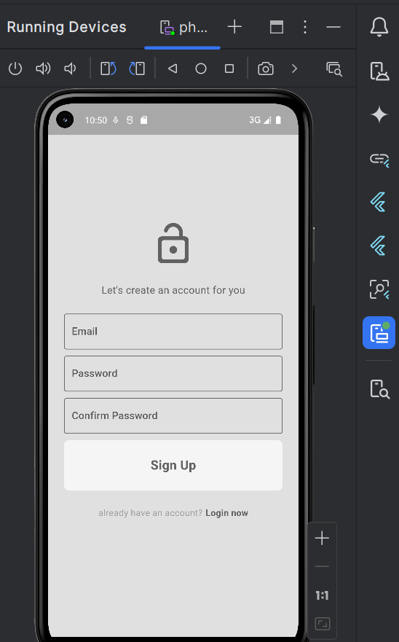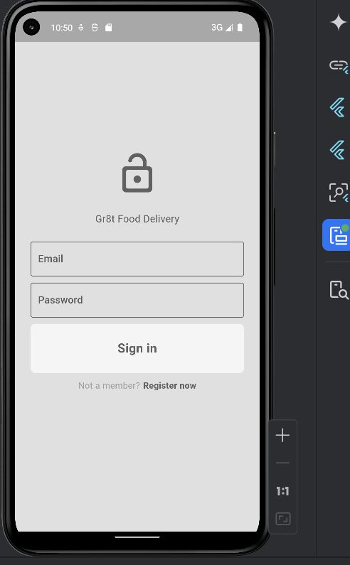

PLACING AN ORDER
Browse Menu: Browse the menu to find your chosen options. Choose the items you desire to order and upgrade them by adding additional items to your selection.

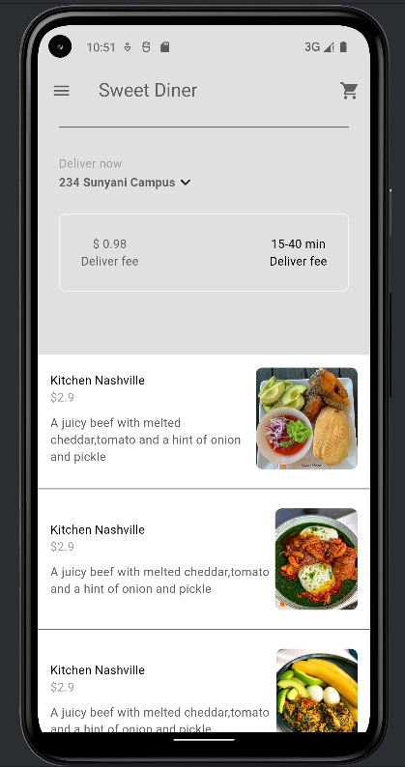

MANAGING YOUR CART
View Cart: Press the Cart icon to look at the items you opted for. You have the option to change the count or erase items from your cart or you can refine the cart altogether by accepting the screen message notifying you of your choices.

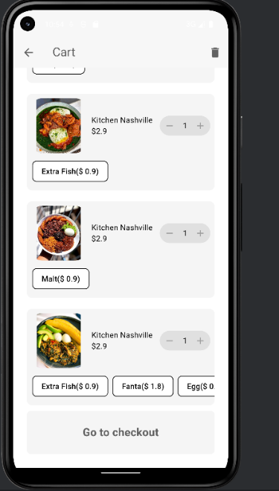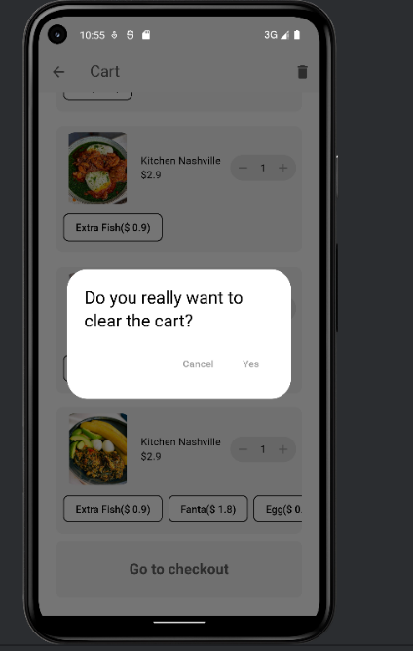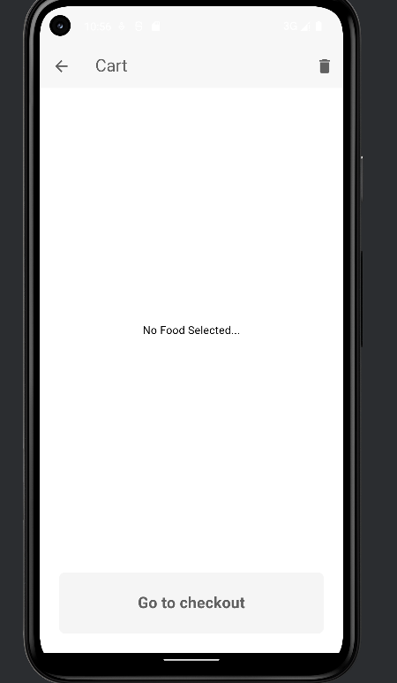

MAKING A PAYMENT
Proceed to Checkout: After confirming your orders 'Move to checkout', Type your payment details and confirm your payment to wrap up your transaction. Following payment, you will observe a notification page showing the details of your order.

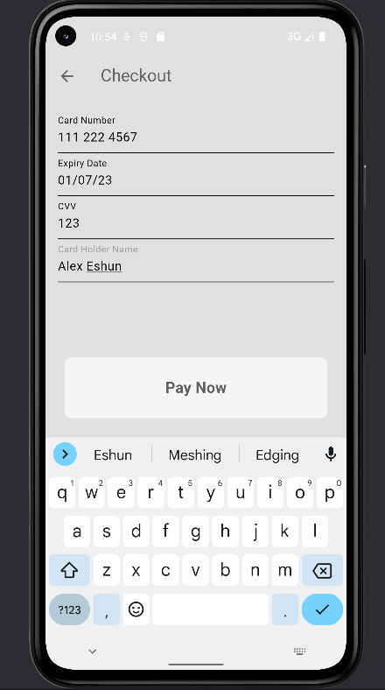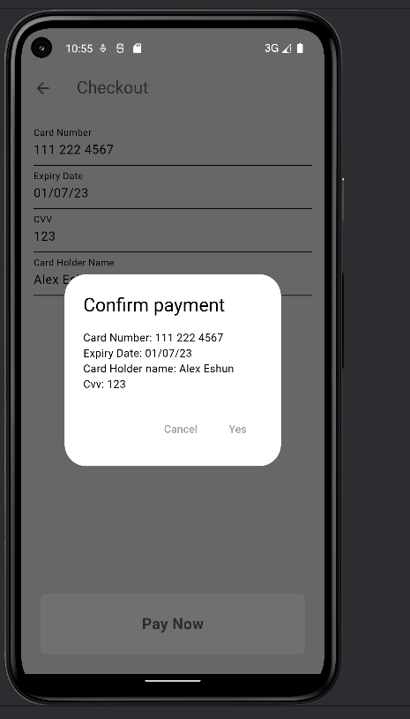

VIEWING YOUR RECEIPT
Receipt Screen: After delivery of your order you will receive the receipt. The receipt contains information on the products chosen together with their prices and the overall cost.
